In TOOLS, go to BOARD and go to NodeMCU 1.0 (ESP-12E Module)

//we will be using this one for the wifi module

**Hazardous Gas Sensor:**

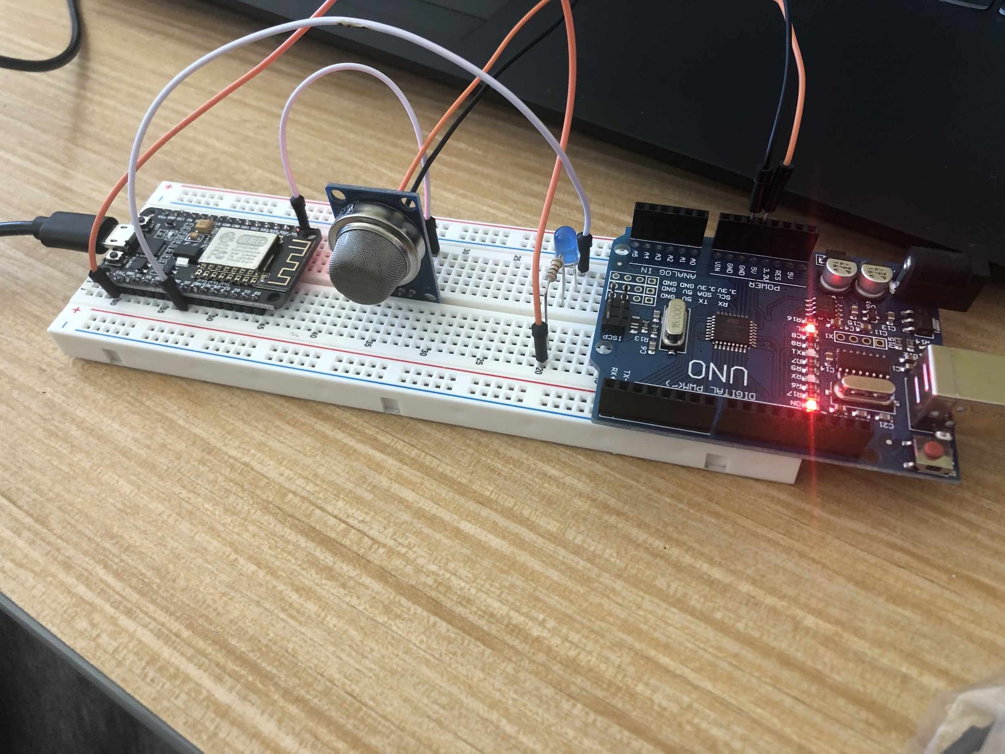

The sensor is powered by the 5V from the arduino UNO. One can also use a different power source that can supply the necessary 5V.

The analog output of the sensor is connected to the A0 input of the Node MCU.

The 3.3V output of the NodeMCU is connected to a 1Kohm resistor in series with the LED cathode.

The anode of the LED is connected to the D5 output of the NodeMCU.